

YOUNG CARER ID CARD

Application form for Young Carers to fill in

A different form (Application for parents and trusted referrers) should be completed if you are a parent/ guardian or trusted referrer applying on behalf of a Young Carer.
You can also apply online for a Young Carer Card by completing the online application on the Ceredigion County Council website: www.ceredigion.gov.uk/youngcarercard
Please read the guidance notes before completing this form. Please make sure you answer all of the required questions and sign the form before sending it to us.
All forms with missing information will be sent back to you to be completed. This will delay your application.
About you
Title (Miss, Mr, Master, etc):
Forename:
Surname:
Address:
Postcode:
Telephone:
Email:
Date of birth:
What is your main language? |  | Welsh | English |  | Bilingual
What language do you want emailed information to be in? |  | Welsh | English |  | Don’t mind/Bilingual
What language do you want posted information to be in? |  | Welsh | English |  | Don’t mind/ Bilingual
What language do you want to use when speaking? |  | Welsh | English |  | Don’t mind/ Bilingual

About you
How many people do you help care for?
1 | 2 | 3+
Who do you help care for? Select all that apply
Mother:
Father:
Sister:
Brother:
Grandfather:
Grandmother:
Other (please tell us who):

Young Carer Info Service
The Young Carer Card is available to members of the Young Carer Info Service. Young Carers will automatically become a member of the service when applying for a Young Carer Card.
Do you want to receive a Young Carer newsletter (sent by email)? |  | Yes |  | No
Do you understand that you can change these preferences at any time by contacting Ceredigion County Council on 01970 633564 or by emailing carersunit@ceredigion.gov.uk |  | Yes |  | No
Do you understand that the Carers Information Service privacy notice stating how data will be processed is available to read and download at www.ceredigion.gov.uk/your-council/data-protection-freedom-of-information/data-protection/privacy-notice/  You can also request a copy by contacting Ceredigion County Council on 01970 633564. |  | Yes |  | No
If you are under 14 years old, we will need to contact your parent/ guardian to get their consent for you to join the Young Carer Info Service and apply for a Young Carer Card.
What is your parent or guardian's name?
What is your parent/ guardian’s phone number?
What is your parent/ guardian’s email address?
If you are 14 or over, please give details of an adult that we can contact about your application if needed. The person could be your parent or guardian or if you prefer, someone you know from school, college, Young Carer Service or other service or from a club or group that you are part of.
Name
Phone Number
Email address
How do you know this person?
Applying for a Young Carer Card
Before applying for a Young Carer Card, please read the terms and conditions and information below.

Terms and conditions
- The Young Carer Card is provided to unpaid Carers age 18 and under who live in Ceredigion or who help care for someone who lives in Ceredigion.

- The Carer Card is available to members of the Young Carer Info Service.

- If the application for a Young Carer card has not been submitted by a trusted referrer, Ceredigion County Council may occasionally ask the Young Carer Card applicant/ cardholder (where appropriate) or parent/ guardian to provide information or evidence of the Young Carer’s caring role, such as a letter from a doctor, school or other appropriate supporting evidence.

- The Young Carer Card is valid for 2 years from the date of issue. It is the parent/ guardian's or Young Carer's responsibility to apply to Ceredigion County Council Carers Unit to renew the card. A trusted referrer may also apply to Ceredigion County Council to renew the card on the Young Carer’s behalf.

- Use of the card is subject to these terms and conditions.

- If a Young Carer's caring role has ended, the parent/ guardian or Young Carer must notify Ceredigion County Council of the change. The Young Carer may carry on using the card for a further 3 months then the card must be returned to Ceredigion County Council.

- Young Carer Cards are issued with photographic identification, a reference number and an expiry date. The Young Carer Card is used for identification purposes and should only be used by the card holder in conjunction with any discount or service offered.

- Ceredigion County Council reserve the right to change the appearance and conditions of the Young Carer Card, or withdraw the Young Carer Card scheme at any time.

- If the Young Carer Card is lost or misplaced, please contact Ceredigion County Council on 01970 633564 and a replacement card can be issued. There may be a small charge for issuing replacement cards.

- Ceredigion County Council reserve the right to change the terms and conditions of this agreement at any time. If we do so, we will notify you in writing at least 30 days before making any such changes, providing details of the changes made.

I understand the terms and conditions of the Young Carer Card and if I am under the age of 14, my parent/ guardian is aware of and understands these terms and conditions. |  |  | Yes
Photo guidelines

Please provide a good quality photo (head & shoulders) of yourself to be used on the card. The picture can be taken on a phone or other device.

You can email a photo to carersunit@ceredigion.gov.uk or post a photo using the address details at the end of this form. If posting a photo, please write your name and date of birth on the back of the photo.

The photo should:
- be a recent colour photo
- be of you alone (no other people or pets)
- be taken against a pale background
- show you facing forwards with your head and shoulders in the photograph
- show your full face
- show you in the centre of the photograph
- if you wear glasses, show your eyes clearly and avoid glare on the lenses

Please be aware of the following restrictions.

Please:
- do not wear a hat or head cover unless for medical or religious reasons
- do not do not submit a photo with red eye
- do not submit a photo where you are in the distance or there are other people visible
- do not submit inappropriate or obscene images
- do not submit a photo in which you have edited to altered your appearance or which has had a filter applied to it
- do not submit an image of someone else or copyright protected images

How your Young Carer Card will look
You can choose the background image on the card from the 6 set images shown here or you can send your own background image to be used on the card. Please select 1 option from the list below.
Card 1:
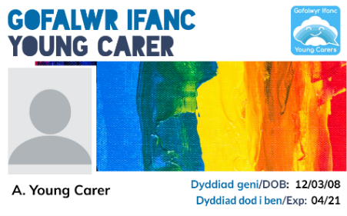

Card 2:
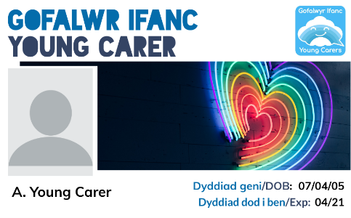
Card 3:
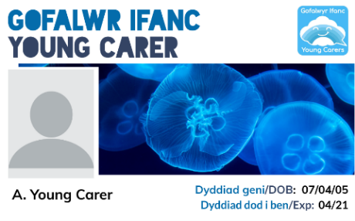
Card 4:
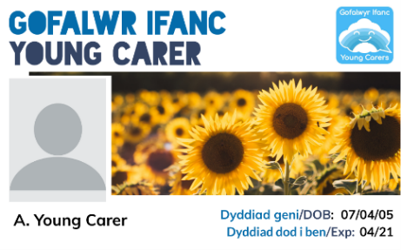
Card 5:
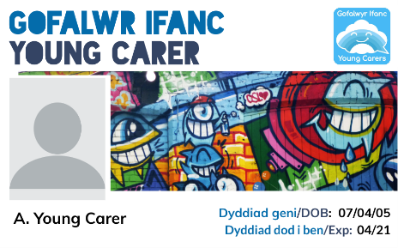
Card 6:
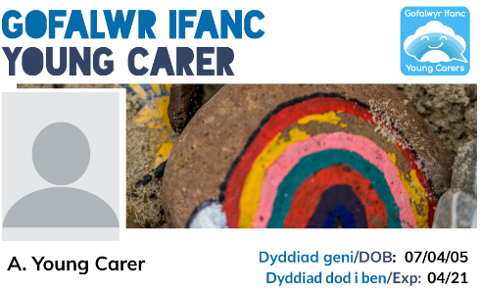
I want to use my own background image on the card. I will send it by email to carersunit@ceredigion.gov.uk.
The background image will:
• be of good quality (in focus and not blurred)
• not be of inappropriate images
• not be an image of someone else or copyright protected images

Please sign and date the form
Signature:
Date:

Please check that you have answered all of the questions and signed and dated the form before returning to:
Email: carersunit@ceredigion.gov.uk

OR
Ceredigion Carers Unit
Ceredigion County Council
Canolfan Rheidol
Rhodfa Padarn
Llanbadarn Fawr
Aberystwyth
SY23 3UE

All forms with missing information will be sent back to you to be completed. This will delay your application.

