

YOUNG CARER ID CARD

Application form for Parents/ Guardians
and Trusted Referrers

This form is for parents/ guardians and trusted referrers who are applying for a Young Carer Card on behalf of a Young Carer.

A different form (Application for Young Carers) should be completed by Young Carer if they are completing the form for them self.
You can also apply online for a Young Carer Card by completing the online application on the Ceredigion County Council website: www.ceredigion.gov.uk/youngcarercard
Please read the guidance notes before completing this form. Please make sure you answer all of the required questions and sign the form before sending it to us.
All forms with missing information will be sent back to you to be completed. This will delay your application.

About you
Title (Miss, Mr, Mrs, Ms, Other (please specify)):
Forename:
Surname:
Address:
Postcode:
Telephone:
Email:
Date of birth:
What is your main language? |  | Welsh | English |  | Bilingual
What language do you want emailed information to be in? |  | Welsh | English |  | Don’t mind/Bilingual
What language do you want posted information to be in? |  | Welsh | English |  | Don’t mind/ Bilingual
What language do you want to use when speaking? |  | Welsh | English |  | Don’t mind/ Bilingual

Your role
Which of the following describes your role?
Parent/ guardian
Trusted referrer
Trusted referrers
(do not fill this section in if you are a parent/ guardian)
If you are a trusted referrer, please select your relevant work area from the following list.
School Service
Young Carer Service
Adult Carer Service
Social Care or other Ceredigion County Council service
NHS/ Health Board
Third sector organisation
Youth service/ youth work
Other (please specify):

If you are a trusted referrer, please provide details about your role:
Organisation name
Department or team
Job title or position
If the Young Carer is under the age of 14, do you have parent/ guardian consent to submit this application?
Yes
No
Not applicable because Young Carer is age 14 or over
Do you have the Young Carer’s consent to submit this application?
Yes
No

About the Young Carer
Title (Miss, Mr, Master, etc):
Forename:
Surname:
Address:
Postcode:
Telephone:
Email:
Date of birth:
What is their main language? |  | Welsh |  | English | Bilingual
What language do they want emailed information to be in? |  | Welsh |  | English | Don’t mind/Bilingual
What language do they want any posted information to be in? |  | Welsh |  | English | Don’t mind/ Bilingual
What language do they want to use when speaking? |  | Welsh |  | English | Don’t mind/ Bilingual

How many people do they help care for?
1 | 2 | 3+
Who do they care for? Select all that apply
Mother:
Father:
Sister:
Brother:
Grandmother:
Grandfather:
Other (please specify):

Young Carer Info Service
The Young Carer Card is available to members of the Young Carers Info Service. Young Carers will automatically become a member of the service when applying for a Young Carer Card.
Does the Young Carer want to receive a Young Carer newsletter (sent by email)? | Yes |  | No
The parent/ guardian/ Young Carer are aware that they can change these preferences at any time by contacting Ceredigion County Council on 01970 633564 or by emailing carersunit@ceredigion.gov.uk. | Yes |  | No
The parent/ guardian/ Young Carer are aware that the Carers Information Service privacy notice stating how data will be processed is available to read and download at http://www.ceredigion.gov.uk/your-council/data-protection-freedom-of-information/data-protection/privacy-notice/.  The parent/ guardian/ Young Carer are aware that they can also request a copy by contacting Ceredigion County Council on 01970 633564. | Yes |  | No
Applying for a Young Carer Card
Before applying for a Young Carer Card, please the terms and conditions and information below.

Terms and conditions
- The Young Carer Card is provided to unpaid Carers age 18 and under who live in Ceredigion or who help care for someone who lives in Ceredigion.

- The Carer Card is available to members of the Young Carer Info Service.

- If the application for a Young Carer card has not been submitted by a trusted referrer, Ceredigion County Council may occasionally ask the Young Carer Card applicant/ cardholder (where appropriate) or parent/ guardian to provide information or evidence of the Young Carer’s caring role, such as a letter from a doctor, school or other appropriate supporting evidence.

- The Young Carer Card is valid for 2 years from the date of issue. It is the parent/ guardian's or Young Carer's responsibility to apply to Ceredigion County Council Carers Unit to renew the card. A trusted referrer may also apply to Ceredigion County Council to renew the card on the Young Carer’s behalf.

- Use of the card is subject to these terms and conditions.

- If a Young Carer's caring role has ended, the parent/ guardian or Young Carer must notify Ceredigion County Council of the change. The Young Carer may carry on using the card for a further 3 months then the card must be returned to Ceredigion County Council.

- Young Carer Cards are issued with photographic identification, a reference number and an expiry date. The Young Carer Card is used for identification purposes and should only be used by the card holder in conjunction with any discount or service offered.

- Ceredigion County Council reserve the right to change the appearance and conditions of the Young Carer Card, or withdraw the Young Carer Card scheme at any time.

- If the Young Carer Card is lost or misplaced, please contact Ceredigion County Council on 01970 633564 and a replacement card can be issued. There may be a small charge for issuing replacement cards.

- Ceredigion County Council reserve the right to change the terms and conditions of this agreement at any time. If we do so, we will notify you in writing at least 30 days before making any such changes, providing details of the changes made.

I understand the terms and conditions of the Young Carer Card.  If I am a Trusted Referrer and the Young Carer is under age 14, I have ensured that the parent/ guardian is aware of and understands these terms and conditions.  If I am a Trusted Referrer and the Young Carer is age 14 or over, I have ensured that the Young Carer is aware of and understands these terms and conditions. |  | Yes
Do you certify that this young person is a Young Carer who meets the eligibility criteria (details below) of the Young Carer Card?  Eligibility criteria  - The Young Carer must not be more than 18 years old.  - The Young Carer must help look after a family member or friend who has a disability, physical or mental illness or is affected by substance or alcohol misuse.  - The Young Carer or the person they care for must live in Ceredigion. |  | Yes
Photo guidelines

Please provide a good quality photo (head & shoulders) of the Young Carer to be used on the card. The picture can be taken on a phone or other device.

You can email a photo to carersunit@ceredigion.gov.uk or post a photo using the address details at the end of this form. If posting a photo, the Young Carer’s name and date of birth should be written on the back of the photo.

The photo should:
- be a recent colour photo
- be of the Young Carer alone (no other people or pets)
- be taken against a pale background
- show the Young Carer facing forwards with head and shoulders in the photograph
- show the Young Carer’s full face
- show the Young Carer in the centre of the photograph
- if the Young Carer wears glasses, show their eyes clearly and avoid glare on the lenses

Please be aware of the following restrictions.

The photo should not:
- show the Young Carer wearing a hat or head cover unless for medical or religious reasons
- show the Young Carer with photographic red eye
- show the Young Carer in the distance or with other people visible
- be of inappropriate or obscene images
- show the Young Carer with edited or altered appearance or with a filter applied
- be an image of someone else or copyright protected images

How the Young Carer Card will look
The Young Carer can choose the background image on the card from the 6 set images shown here or they can choose their own background image for use on the card on the card. Please select 1 option from the list below.
Card 1:
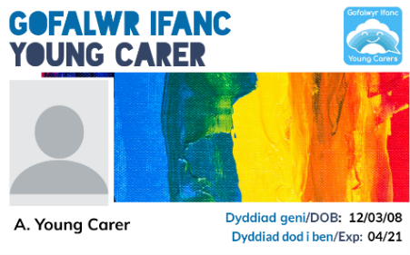
Card 2:
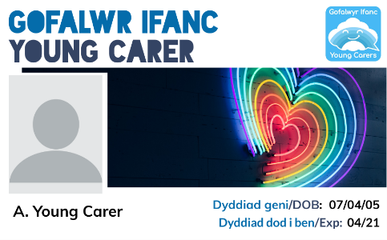

Card 3:
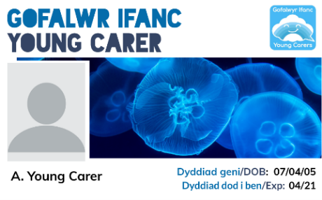

Card 4:
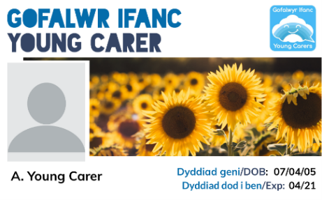
Card 5:
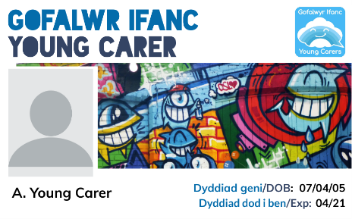
Card 6:
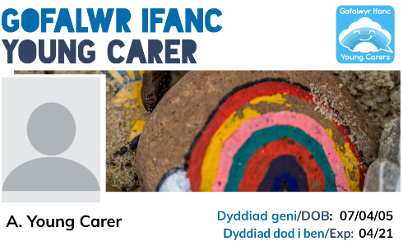
The Young Carer wants to use their own background image on the card. The image will be sent by email to carersunit@ceredigion.gov.uk.
The background image will:
- be of good quality (in focus and not blurred)
- not be of inappropriate images
- not be an image of someone else or copyright protected images

Please sign and date the form
Signature:
Date:

Please check that you have answered all of the questions and signed and dated the form before returning to:
Email: carersunit@ceredigion.gov.uk

OR
Ceredigion Carers Unit
Ceredigion County Council
Canolfan Rheidol
Rhodfa Padarn
Llanbadarn Fawr
Aberystwyth
SY23 3UE

All forms with missing information will be sent back to you to be completed. This will delay your application.

