A.7. Identity Card

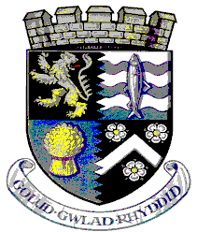


CYNGOR SIR CEREDIGION COUNTY COUNCIL

Adran Arfordir a Chefn Gwlad

Coast and Countryside Section
Neuadd Cyngor Ceredigion, Penmorfa, Aberaeron,
Ceredigion SA46 0PA

Ceredigion County Council’s [INSERT PROJECT NAME] Information Card
I am a volunteer working on behalf of Ceredigion County Council. I am part of the Council’s [INSERT PROJECT NAME]. I am authorised to undertake works identified in the Memorandum of Understanding, surveying and taking photographs as necessary. If you would like further information, please contact [INSERT STAFF MEMBER AS APPROPRIATE].

