RESIDENTS QUESTIONNAIRE

Review of Houses in Multiple Occupation (HMOs) Mandatory and Additional Licensing Schemes for Ceredigion
The Housing Act 2004 introduced a requirement for certain Houses in Multiple Occupation (HMO’s) to be licensed. This enables Local Authorities to ensure that HMOs are suitably equipped with amenities and facilities for the number of occupants residing in them and are effectively managed by 'fit and proper persons'.
HMOs are rented houses which are shared by more than one household, for example, shared student houses and houses converted into flats/bedsits.
The Mandatory Licensing Scheme applies to larger, high-risk HMOs of 5 or more occupants and of 3 or more storeys.
The Additional Licensing Scheme is a discretionary licensing scheme. Since April 2019 Ceredigion County Council has run an Additional Licensing scheme which has incorporated the following.
- HMOs occupied by three or more persons, forming three or more separate households regardless of the number of storeys in the following specified wards only:

i. Aberystwyth Bronglais
ii. Aberystwyth Central
iii. Aberystwyth North
iv. Aberystwyth Penparcau
v. Aberystwyth Rheidol
vi. Faenor
vii. Llanbadarn Fawr Padarn
viii. Llanbadarn Fawr Sulien

- The whole of the County of Ceredigion for:

- HMOs occupied by 5 or more persons, forming two or more separate households, regardless of the number of storeys, and
- Section 257 HMOs (Housing Act 2004)
This Additional scheme is due to end in April 2024 and the Council is reviewing whether this scheme should be continued in its current form, extended, reduced or otherwise changed.
The results of this questionnaire will enable Ceredigion County Council to ensure that the HMO Mandatory and Additional Licensing Schemes that operate in the County are achieving the desired outcomes and will be used to address any concerns in future schemes that we may introduce.
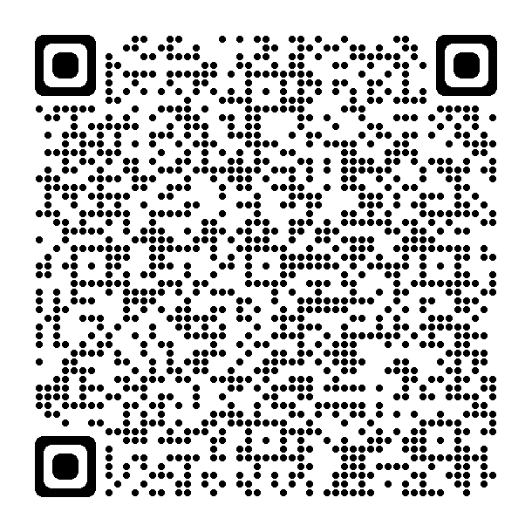
The consultation will close on Friday 23rd February2024
You can also complete the survey online via Ceredigion County Council Engagement and Consultation webpage or via this QR code.

- What is the postcode of your home address?

- Which of these best describes you?

☐ Private Tenant ☐ Social housing tenant
☐ Owner Occupier ☐ Landlord ☐ Letting Agent
- What kind of property do you live in? (Owner occupiers and tenants only) (please tick):

☐ Flat single family occupancy
☐ House single family occupancy
☐ Shared house with others (not one family)
☐ Shared flat with others (not one family)

If flat, how many flats are there in the block?

If shared house or flat, how many people live there?

How many storeys are there in the house/flat you live in?

- How long have you lived at the property?

Questions 5 - 10 are for tenants only.

- If you are a tenant, please provide details of what was provided by your landlord when you moved in? Tick all that apply

☐ Written Tenancy Agreement
☐ Information about refuse collection days
☐ Details of how deposit is protected
☐ Your responsibilities as a tenant
☐ Copy of gas safety certificate
☐ Copy of energy performance certificate
☐ Inventory
☐ Location of gas, electric, water meters
☐ How to silence fire alarm
☐ Rent book

- If you are a tenant, are you concerned about any of the following in relation to your home?

☐ Not enough amenities (i.e. toilet, kitchen facilities)
☐ Waste, storage and refuse
☐ Fire safety
☐ Too little space/too many people
☐ Security
☐ Efficient heating system/ adequate insulation (Energy Efficiency)
☐ Property in poor state of repair
☐ Damp and mould
☐ Security of your tenancy (getting evicted)
☐ Other, please specify

- If you are a tenant, are you aware of the requirement for landlords to be licenced under Rent Smart Wales?

☐ Yes ☐ No

- Do you think that the Rent Smart Wales Scheme has improved the quality of your home or relationship with your landlord?

☐ Yes ☐ No

Please explain further.

- Do you think that landlords and agents manage your property or other properties in your area to an acceptable standard?

☐ Yes ☐ No ☐ Don’t Know

Please comment further if necessary:

- Do you think Rent Smart Wales licencing of landlords is enough to ensure proper management of your property?

☐ Yes ☐ No ☐ Don’t Know

Please comment further if necessary:

These questions are for ALL

- Are you concerned about any of the following in relation to your area?
☐ Noise, nuisance
☐ Litter, waste and refuse
☐ Unkempt and overgrown gardens/forecourts
☐ Properties detrimental to the amenity of the area (untidy properties)
☐ Burglary
☐ Anti-Social Behaviour
☐ Other crime
☐ Other, please specify

- Do you have any ideas about how these could be tackled?

- Do you think that the Licensing Scheme for HMOs benefits the community?

☐ Yes ☐ No ☐ Don’t Know

Please comment further if necessary:

- Do you think a HMO Licensing Scheme benefits tenants of HMOs?

☐ Yes ☐ No ☐ Don’t Know

Please comment further if necessary:

- Do you support the continuation/ introduction of an Additional licencing scheme?
☐ Yes ☐ No ☐ Don’t Know ☐ Depends on the scheme/ in part
Please explain your answer:

- Please indicate which of the following types of property you would like to see licenced?

☐ A dwelling shared by 5 persons or more and 3 storeys or more – This is mandatory and will continue
☐ A dwelling occupied by one family
☐ A dwelling shared by 2 or more families/ households
☐ A dwelling shared by a family/household and a non-related lodger
☐ A dwelling shared by a family/ household with two or more lodgers
☐ A dwelling shared by three single people, not related
☐ A dwelling shared by four single people, not related
☐ A dwelling shared by five or more single people, not related

- Do you think the number of storeys should be taken into consideration as part of the licensing scheme?

☐ Yes ☐ No
If yes, what number of storeys should be licensed? No. of floors? …….

Please return this questionnaire to the following address:
Ceredigion County Council, Community Wellbeing Service
Canolfan Rheidol
Aberystwyth
Ceredigion
SY23 3UE
Ref: Additional Licensing Review 2023

Email: housing@ceredigion.gov.uk

The consultation will close on Friday 23rd February2024

Equality Monitoring Form


These questions are optional, but we need to ask them to understand if our consultation has reached the right people (in accordance with the requirement of the Equality Act 2010) and to understand how different groups may be affected by the proposal allowing us to address this if we can.
In accordance with the Data Protection Act, any information requested on the following questions is held in the strictest confidence for data analysis purposes only.
1. Age: What is your age group?
Under 16 |  | 45 – 64 years
16 – 24 years |  | 65+
25 – 44 years |  | Prefer not to say

2. Gender: What is your gender?
Male |  |  |  |  | Female
Other |  |  |  |  | Prefer Not To Say
3. Transgender: Is your gender the same now as when assigned at birth?
Yes |  |  | No |  |  | Prefer not to say

4. Sexual Orientation: Which of the following options best describes how you think of yourself?
Heterosexual/Straight |  | Bisexual
Gay Man |  | Prefer not to say
Gay Woman/Lesbian |  | Other (state if desired) _______________________
Note: This question should only be asked of people age over 16.

5. Partnership: Which of the following options describes your partnership status?
Single |  | Widowed
Married |  | Civil Partnership
Living with Partner |  | Separated
Divorced  Prefer not to say |  | Other

6. National identity: How would you describe your national identity?
Welsh |  | British
English |  | Irish
Scottish |  | Prefer not to say
Northern Irish |  | Other (please describe) _____________________________________

7. Race: What is your ethnic group? Choose one option that best describes your ethnic group or background.
White |  | Gypsy Travellers
Asian |  | Prefer not to say
Black/African/Caribbean |  | Other (Please State)
Mixed |  | ______________________________________

8. Language: What is your preferred language?
Welsh |  | Prefer not to say
English |  | Other (including British Sign Language)  ______________________________________________
Can you understand, speak, read or write Welsh?
Understand spoken Welsh |  |  |  | Write Welsh
Speak Welsh |  |  |  | None of the above
Read Welsh |  |  |  | Prefer not to say

9. Disability: Do you have a long term physical or mental health condition or illness that reduces your ability to carry out day to day activities
Yes |  |  |  | No
Prefer not to say
If you answered ‘Yes’ please indicate which applies to you:
Hearing Impairment |  |  | Mental Health Issues
Visual Impairment |  |  | Physical / Mobility Impairment
Speech Impairment |  |  | Prefer not to say
Learning Difficulties |  |  | Other (please specify)

10. Caring Responsibilities: Do you look after or give help or support to family members, friends, neighbours or others because of long term physical or mental ill-health, disability or problems related to old age?
Yes |  | No |  | Prefer not to say

11. Religion or Belief: What is your religion?
Christian (all denominations) |  | Jewish
Buddhist |  | Atheist
Hindu |  | No religion
Muslim |  | Prefer not to say
Sikh |  | Other
Thank you for completing this form.

